# LAB EXPERIMENT 06

# Implementation of Newton’s Divided Difference Formula using MATLAB

## Objective:

To find value in between the given data point by using Newton’s Divided Difference Formula through MATLAB

## Theory:

For Newton’s divided difference method let us revisit the quadratic polynomial interpolation formula



where







Note that  and  are finite divided differences. And  are the first, second, and third finite divided differences, respectively. We denote the first divided difference by



the second divided difference by



and the third divided difference by





where  and  are called bracketed functions of their variables enclosed in square brackets.

Rewriting,



This leads us to writing the general form of the Newton’s divided difference polynomial for  data points, , as



where













where the definition of the  divided difference is





From the above definition, it can be seen that the divided differences are calculated recursively.

## Problem Statement:

# Interpolate the Value of ‘y’ at x=7 from the given Data points through MATLAB:

|  |  |  |  |  |
| --- | --- | --- | --- | --- |
| X | 6 | 9 | 10 | 12 |
| Y | 1.1791 | 1.197 | 2.302 | 2.485 |

## MATLAB Code:

|  |
| --- |
| clear all, clc    %% Defining Variables and Matrix    v = [6 1.1791;  9 1.197;  10 2.302;  12 2.485];  x = 7;    %% Code    len = length(v) - 1;  B = zeros(len);    B(1,1) = (v(2,2) - v(1,2)) / (v(2,1) - v(1,1));  B(2,1) = (v(3,2) - v(2,2)) / (v(3,1) - v(2,1));  B(3,1) = (v(4,2) - v(3,2)) / (v(4,1) - v(3,1));    B(1,2) = (B(2,1) - B(1,1)) / (v(3,1) - v(1,1));  B(2,2) = (B(3,1) - B(2,1)) / (v(4,1) - v(2,1));    B(1,3) = (B(2,2) - B(1,2)) / (v(4,1) - v(1,1));    NewtonTable = B;    y1 = v(1,2) + ((x - v(1,1))*(NewtonTable(1,1)));  y2 = ((x - v(1,1))*(x - v(2,1))*(NewtonTable(1,2)));  y3 = ((x - v(1,1))*(x - v(2,1))*(x - v(3,1))*(NewtonTable(1,3)));  y = y1 + y2 + y3;    %% Output    fprintf("Newton's divided difference table is: \n")  NewtonTable    fprintf("\nAt X = %.4f, after interpolation, Y Value = %.4f \n", x, y) |

## Results:

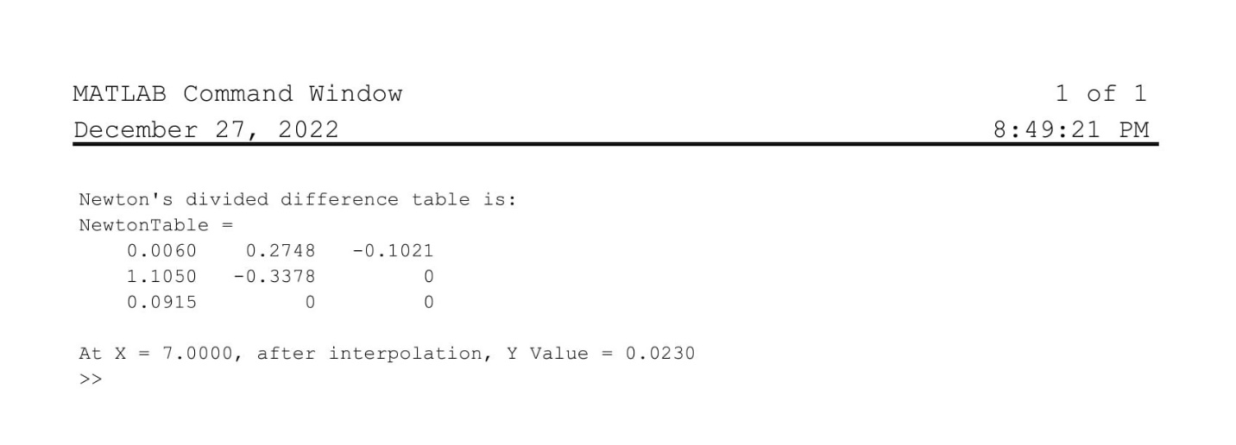

## Discussion

Comments will be made on the following

1. Write different Interpolation methods along with their application conditions?

1. Which method can be used to interpolate this data instead of Newton Divided difference Formula and why?